Science Lab Report

|  |  |  |
| --- | --- | --- |
| **Lab partners (name, student #):**  Sven Bröcking #30792  Natalia Ann Kolodziej #28691 | **degree course, semester:**  **1**  **3** | |
| **Performed the experiment on: Name of the tutor: *Accepted:***  **Yes**  **No**  **Submission of the report: Checked on: Submission of first revision: Checked on: Submission of second revision: Checked on:**  ***Title:***  Kinematics | | |
|  | | |
| Remarks of the tutor: | |  |

# Theory

The purpose of this experiment is to record the position-time curve and the velocity-time curve for the two fundamental types of movement, the movement with constant velocity and the movement with constant acceleration. In addition, a velocity-position plot should be recorded for the two types of movement. The recorded curves are then used to determine the velocity and the acceleration in the two cases. The curves are described by the following formulas:

|  |  |  |
| --- | --- | --- |
|  | constant velocity | constant acceleration |
| position-time relation | 𝑥(𝑡) = 𝑣0𝑡 + 𝑥0 | 1  𝑥(𝑡) = 𝑎0𝑡2 + 𝑣0𝑡 + 𝑥0 2 |
| velocity-time realtion | 𝑣(𝑡) = 𝑣0 | 𝑣(𝑡) = 𝑎0𝑡 + 𝑣0 |
| velocity-position relation | 𝑣(𝑥) = 𝑣0 | 𝑣(𝑥) = √𝑣2 + 2𝑎 (𝑥 − 𝑥 )  0 0 0 |

# Setup

The experimental setup consists of a track with a cart. The cart is started with a starter system or accelerated with a pulling weight or by inclining the track. Light barriers are positioned at four positions and with a flag attached to the cart one can measure the arrival time of the cart or the blackout time of the light barrier.

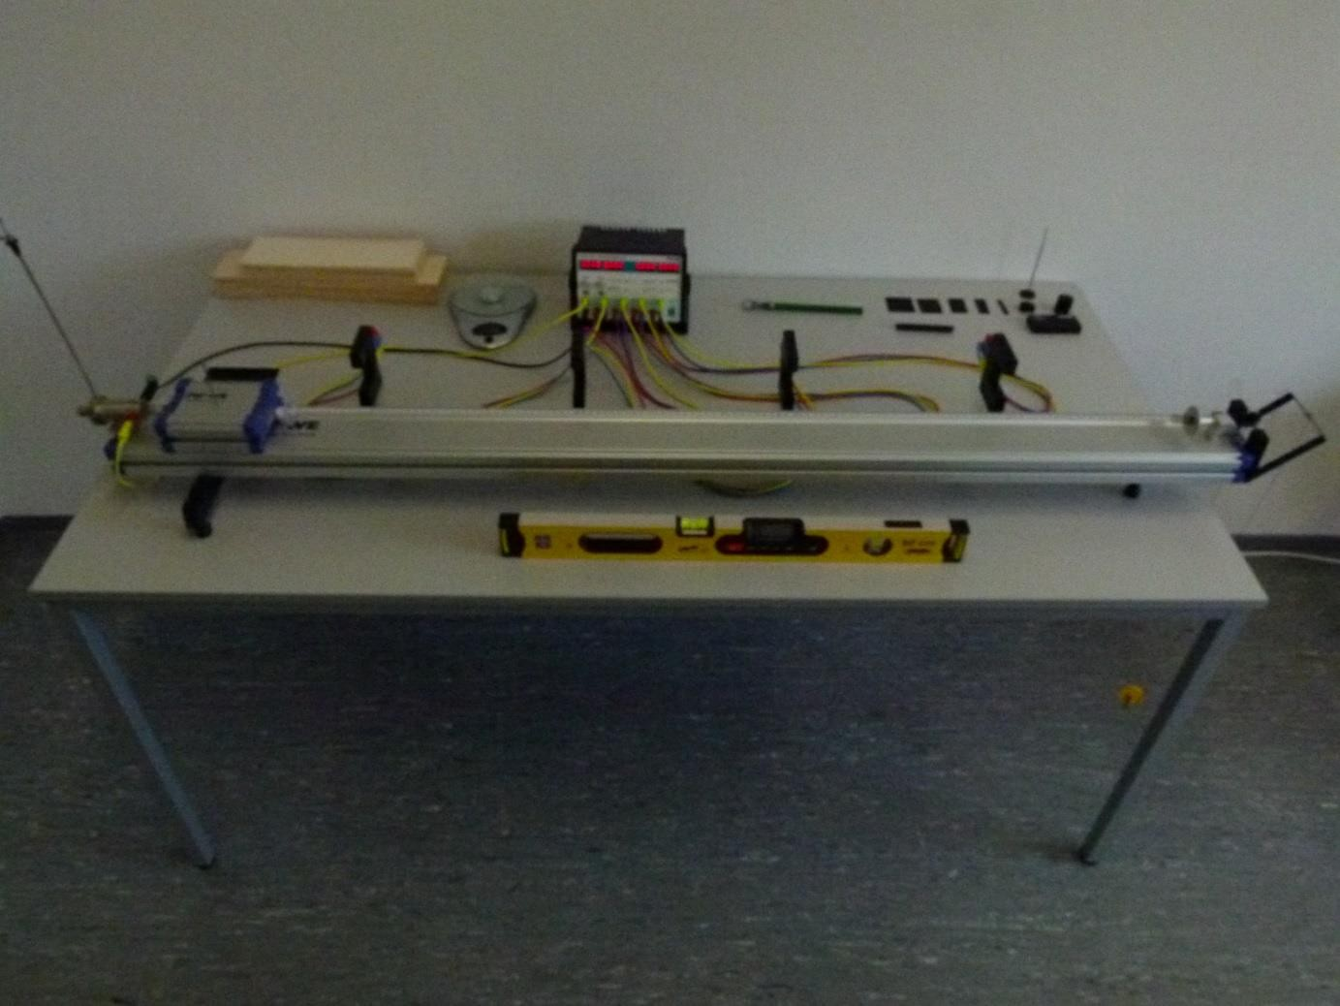

Figure 1: The experimental setup

# Evaluation

## 1a) Position-time plot for constant velocity

### Step 1: The data

The light barriers were fixed at the positions *x*1 = 30 cm, *x*2 = 60 cm, *x*3 = 90 cm and *x*4 = 120 cm with an uncertainty of *u*(*x*i ) = ±0.1 cm. The following tables contain the *N*=3 measured arrival times and their mean and uncertainty calculated with the formula:

𝑡 ± (𝑡) = 1 ∑𝑁

𝑡 ± 𝑡

1 √ 1

∑𝑁

(𝑡

− )2, (1)

𝑁 𝑖=1 𝑖

(𝑁−1,95%) √𝑁

𝑁−1

𝑖=1 𝑖

using the student-t-factor 𝑡(2,95%)**=** 4.303.

|  |  |  |  |  |
| --- | --- | --- | --- | --- |
| stage 1 | | | | |
|  | 30 cm | 60 cm | 90 cm | 120 cm |
| measurement | arrival times in s | arrival times in s | arrival times in s | arrival times in s |
| 1 | 0.372 | 1.393 | 2.371 | 3.324 |
| 2 | 0.375 | 1.402 | 2.388 | 3.350 |
| 3 | 0.379 | 1.421 | 2.422 | 3.398 |
| mean 𝑡 in s | 0.375 | 1.405 | 2.393 | 3.357 |
| *u*(𝑡) in s | 0.009 | 0.036 | 0.065 | 0.093 |

|  |  |  |  |  |
| --- | --- | --- | --- | --- |
| stage 3 | | | | |
|  | 30 cm | 60 cm | 90 cm | 120 cm |
| measurement | arrival times in s | arrival times in s | arrival times in s | arrival times in s |
| 1 | 0.178 | 0.671 | 1.152 | 1.634 |
| 2 | 0.180 | 0.678 | 1.163 | 1.649 |
| 3 | 0.179 | 0.671 | 1.151 | 1.632 |
| mean 𝑡 in s | 0.179 | 0.673 | 1.155 | 1.638 |
| *u*(𝑡) in s | 0.003 | 0.010 | 0.017 | 0.023 |

Table 1: The arrival times for the case of constant velocity with their mean values and uncertainties.

### Step 2: The plots

The position-time plots are obtained by plotting the positions against the corresponding mean values of the arrival times. For the case of constant velocity position and time are related by the linear position-time law

(𝑡) = 𝑣0𝑡 + 𝑥0, (2)

i.e., a linear regression is performed for the data points of stage 1 and the data points of stage 3.

The slope of the regression line corresponds then to the velocity 𝑣0 and the intercept of the regression line corresponds to the front edge 𝑥0 of the cart at its start position.

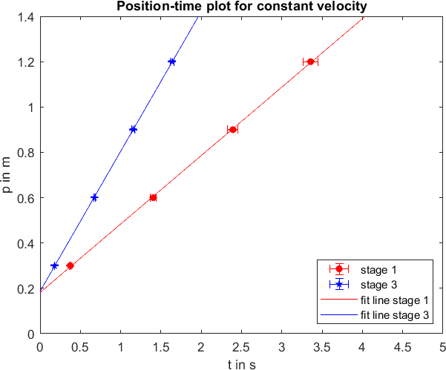

Figure 2: The position-time plots for constant velocity.

The regression lines are given by:

stage 1: 𝑥1(𝑡) = (𝑎1 ± 𝑠𝑎1)𝑡 + (𝑏1 ± 𝑠𝑏1) = (0.3019 ± 0.016)𝑡 + ( 0.1815 ± 0.010 ), (3) stage 3: 𝑥3(𝑡) = (𝑎3 ± 𝑠𝑎3)𝑡 + (𝑏3 ± 𝑠𝑏3) = (0.6173 ± 0.032 )𝑡 + ( 0.1874 ± 0.010 ). (4)

### Step 3: The results and answer to the question

The measurement values for the velocity follow from the slope of the regression lines:

velocity in stage 1: 𝑣0 ± 𝑢(𝑣0) = ( 0.3019 ± 0.016 ) 𝑚/𝑠 , (5)

velocity in stage 3: 𝑣0 ± 𝑢(𝑣0) = ( 0.6173 ± 0.032 ) 𝑚/𝑠 . (6) The positions of the front edge of the cart follows from the intercept of the regression line:

front edge position in stage 1: 𝑥0 ± 𝑢(𝑥0) = ( 0.1815 ± 0.010 ) 𝑚 , (7)

front edge position in stage 3: 𝑥0 ± 𝑢(𝑥0) = ( 0.1874 ± 0.010 ) 𝑚 . (8)

## 1b) Velocity-time plot and velocity-position plot for constant velocity

### Step 1: The data

The light barriers are now measuring the blackout times *tbl*. Mean and uncertainty of the blackout times are calculated as in 1a). The velocity at the corresponding light barrier is calculated with the length 𝑙 ± (𝑙) = (10 ± 0.1) cm of the flag:

𝑙 1 2 −𝑙 2 2

𝑣 ± 𝑢(𝑣) =

𝑡𝑏𝑙

± √( )

𝑡𝑏𝑙

((𝑙))2 + ( 2)

𝑡𝑏𝑙

(𝑢(𝑡𝑏𝑙)) . (9)

|  |  |  |  |  |
| --- | --- | --- | --- | --- |
| stage 1 | | | | |
|  | 30 cm | 60 cm | 90 cm | 120 cm |
| measurement | blackout times in s | blackout times in s | blackout times in s | blackout times in s |
| 1 | 0.336 | 0.332 | 0.317 | 0.307 |
| 2 | 0.335 | 0.330 | 0.315 | 0.306 |
| 3 | 0.331 | 0.326 | 0.312 | 0.303 |
| mean 𝑡𝑏𝑙 in s | 0.334 | 0.329 | 0.315 | 0.305 |
| *u*(𝑡𝑏𝑙) in s | 0.007 | 0.008 | 0.006 | 0.005 |
| velocity *v* in m/s | 29.940 | 30.395 | 31.746 | 32.787 |
| *u*(*v*) in m/s | 0.695 | 0.799 | 0.683 | 0.630 |

|  |  |  |  |  |
| --- | --- | --- | --- | --- |
| stage 3 | | | | |
|  | 30 cm | 60 cm | 90 cm | 120 cm |
| measurement | blackout times in s | blackout times in s | blackout times in s | blackout times in s |
| 1 | 0.162 | 0.163 | 0.160 | 0.159 |
| 2 | 0.161 | 0.161 | 0.159 | 0.158 |
| 3 | 0.164 | 0.165 | 0.162 | 0.161 |
| mean 𝑡𝑏𝑙 in s | 0.162 | 0.163 | 0.160 | 0.159 |
| *u*(𝑡𝑏𝑙) in s | 0.004 | 0.005 | 0.004 | 0.004 |
| velocity *v* in m/s | 61.728 | 61.350 | 62.5 | 62.893 |
| *u*(*v*) in m/s | 1.644 | 1.979 | 1.683 | 1.703 |

Table 2: The blackout times for the case of constant velocity together with the velocities and their uncertainties.

### Step 2: The plots

The velocity-time plots are obtained by plotting the velocities of table 2 against the mean arrival times at the corresponding position given in table 1. For the case of constant velocity and time are related by the linear velocity-time law

(𝑡) = 𝑣0, (10)

i.e., a linear regression is performed for the data points of stage 1 and the data points of stage 3.

The slope of the regression line should then be close to zero and the intercept of the regression line corresponds to the initial velocity 𝑣0 of the cart.

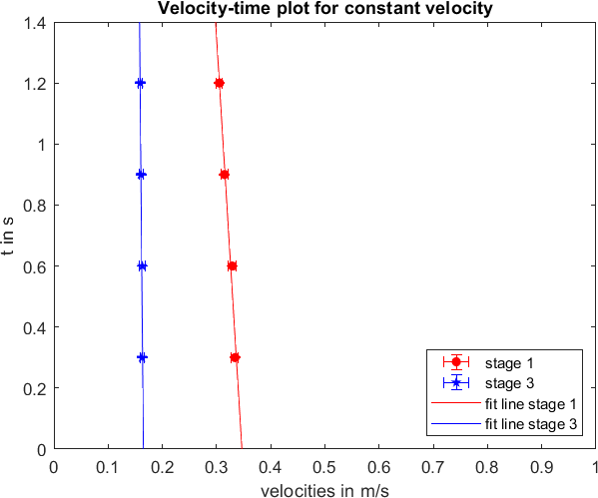

Figure 3: The velocity-time plots for constant velocity.

The regression lines are given by:

stage 1: 𝑣1(𝑡) = (𝑎1 ± 𝑠𝑎1)𝑡 + (𝑏1 ± 𝑠𝑏1) = ( 28.8200 ± 1.5168 )𝑡 + ( 9.9970 ± 0.5262 ), (11) stage 3: 𝑣3(𝑡) = (𝑎3 ± 𝑠𝑎3)𝑡 + (𝑏3 ± 𝑠𝑏3) = ( 200 ± 10.5263 )𝑡 + ( 33 ± 1.7368 ). (12)

The velocity-position plot is obtained, by plotting the velocities from table 2 against the corresponding positions of the light barriers. For the case of constant velocity, the velocity and the position are connected by the linear velocity-position relation

(𝑥) = 𝑣0, (13)

i.e. for the data points of stage 1 and stage 3 one calculates a regression line. The slope of the regression line should be approximately zero and the intercept corresponds again to the initial velocity 𝑣0 of the cart.

The regression lines of the velocity-position plot are given by:

stage 1: 𝑣1(𝑡) = (𝑎1 ± 𝑠𝑎1)𝑥 + (𝑏1 ± 𝑠𝑏1) = ( 0 ± )𝑡 + ( 0.346 ± ), (14) stage 3: 𝑣3(𝑡) = (𝑎3 ± 𝑠𝑎3)𝑥 + (𝑏3 ± 𝑠𝑏3) = ( 0 ± )𝑡 + ( 0.164 ± ). (15)

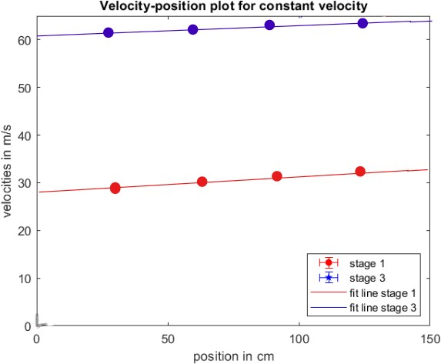

Figure 4: The velocity-position plot for constant velocity.

### Step 3: The results and answers to the question

For the determination of the acceleration and the initial velocity one uses the velocity-time plot. The slop in the velocity-time plot should be close to zero in the case of constant velocity, but there is a small negative acceleration appears due to friction. It is given by the slope of the regression line:

acceleration in stage 1: 𝑎0 ± 𝑢(𝑎0) = ( 0 ± 0.1 ) 𝑚/𝑠^2 , (16)

acceleration in stage 3: 𝑎0 ± 𝑢(𝑎0) = ( 0 ± 0.1 ) 𝑚/𝑠^2 . (17)

The measurement value for the initial velocity of the cart follows from the intercept of the regression line in the velocity-time plot:

initial velocity in stage 1: 𝑣0 ± 𝑢(𝑣0) = ( 0.346 ± 0.018 ) 𝑚/𝑠 , (18)

initial velocity in stage 3: 𝑣0 ± 𝑢(𝑣0) = ( 0.164 ± 0.09 ) 𝑚/𝑠 . (19)

## 2a) Position-time plot for constant acceleration

### Step 1: The data

The mean values and uncertainties are calculated just as in 1a).

|  |  |  |  |  |
| --- | --- | --- | --- | --- |
| 20 g weight | | | | |
|  | 30 cm | 60 cm | 90 cm | 120 cm |
| measurement | arrival times in s | arrival times in s | arrival times in s | arrival times in s |
| 1 | 0.932 | 1.774 | 2.324 | 2.770 |
| 2 | 0.927 | 1.768 | 2.316 | 2.760 |
| 3 | 0.924 | 1.752 | 2.298 | 2.742 |
| mean 𝑡 in s | 0.928 | 1.765 | 2.313 | 2.757 |
| *u*(𝑡) in s | 0.003 | 0.007 | 0.008 | 0.009 |

|  |  |  |  |  |
| --- | --- | --- | --- | --- |
| 40 g weight | | | | |
|  | 30 cm | 60 cm | 90 cm | 120 cm |
| measurement | arrival times in s | arrival times in s | arrival times in s | arrival times in s |
| 1 | 0.694 | 1.329 | 1.741 | 2.076 |
| 2 | 0.706 | 1.341 | 1.754 | 2.088 |
| 3 | 0.705 | 1.339 | 1.751 | 2.086 |
| mean 𝑡 in s | 0.702 | 1.336 | 1.749 | 2.083 |
| *u*(𝑡) in s | 0.004 | 0.004 | 0.004 | 0.004 |

Table 3: The arrival times for the case of constant acceleration with their mean values and uncertainties.

### Step 2: The plots

The position-time plots are obtained by plotting the positions against the corresponding mean values of the

arrival times. In the performed experiment the initial velocity was 𝑣0

= 0 𝑚. In this case the position-time

𝑠

relation for constant acceleration reduces to:

𝑥(𝑡)

1

= 2 𝑎0𝑡

2

+ 𝑥0

, (20)

where 𝑥0 is again the start position. This means that the data points have to be fitted by a parabola without linear term.

The fit parameter of the quadratic part corresponds then to one half of the acceleration and the intercept of the parabola corresponds again to the front edge 𝑥0 of the cart at its start position.

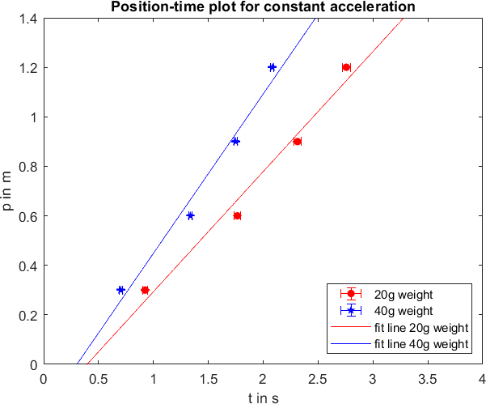

Figure 5: The position-time plots for constant acceleration.

The fit-parabolas are given by:

20 g: 𝑥20(𝑡) = (𝑎20 ± 𝑠𝑎20)𝑡2 + (𝑐20 ± 𝑠𝑐20) = ( 0.4853 ± 0.0255 )𝑡2 + ( − 0.1913 ± 0.1007 ), (21)

40 g: 𝑥40(𝑡) = (𝑎40 ± 𝑠𝑎40)𝑡2 + (𝑐40 ± 𝑠𝑐40) = ( 0.6437 ± 0.0339 )𝑡2 + ( − 0.6533 ± ). (22)

### Step 3: The results and answer to the question

The measurement value for the acceleration follows by multiplying the fit parameter of the quadratic part by two. The error of the acceleration also has to be doubled:

acceleration for 20 g weight: 𝑎0 ± 𝑢(𝑎0) = ( 0.9706 ± 0.0510 ) , (23)

acceleration for 40 g weight: 𝑎0 ± 𝑢(𝑎0) = ( 1.2874 ± 0.0678 ) . (24)

## 2b) Velocity-time plot and velocity-position plot for constant acceleration

### Step 1: The data

The mean values and uncertainties for the blackout times are calculated as in the case of 1b) just as the velocities and uncertainties of the velocities.

|  |  |  |  |  |
| --- | --- | --- | --- | --- |
| 20 g weight | | | | |
|  | 30 cm | 60 cm | 90 cm | 120 cm |
| measurement | blackout times in s | blackout times in s | blackout times in s | blackout times in s |
| 1 | 0.335 | 0.202 | 0.156 | 0.133 |
| 2 | 0.334 | 0.201 | 0.157 | 0.132 |
| 3 | 0.333 | 0.201 | 0.156 | 0.133 |
| mean 𝑡𝑏𝑙 in s | 0.334 | 0.201 | 0.156 | 0.133 |
| *u*(𝑡𝑏𝑙) in s | 0.003 | 0.001 | 0.001 | 0.001 |
| velocity *v* in m/s | 29.940 | 49.751 | 64.100 | 75.188 |
| *u*(*v*) in m/s | 0.402 | 0.556 | 0.761 | 0.941 |
| 2 𝑚2  𝑣 in 2  𝑠 | 896.411 | 2475.19 | 4109.14 | 5653.23 |
| 2 𝑚2  𝑢(𝑣 ) in 2  𝑠 | 0.162 | 0.309 | 0.580 | 0.885 |

|  |  |  |  |  |
| --- | --- | --- | --- | --- |
| 40 g weight | | | | |
|  | 30 cm | 60 cm | 90 cm | 120 cm |
| measurement | blackout times in s | blackout times in s | blackout times in s | blackout times in s |
| 1 | 0.248 | 0.150 | 0.117 | 0.100 |
| 2 | 0.245 | 0.150 | 0.117 | 0.100 |
| 3 | 0.244 | 0.150 | 0.116 | 0.100 |
| mean 𝑡𝑏𝑙 in s | 0.246 | 0.150 | 0.117 | 0.100 |
| *u*(𝑡𝑏𝑙) in s | 0.005 | 0.000 | 0.001 | 0.000 |
| velocity *v* in m/s | 40.650 | 66.667 | 85.470 | 100 |
| *u*(*v*) in m/s | 0.921 | 0.667 | 1.124 | 1 |
| 2 𝑚2  𝑣 in 2  𝑠 | 1652.46 | 4444.44 | 7305.14 | 10000 |
| 2 𝑚2  𝑢(𝑣 ) in 2  𝑠 | 0.848 | 0.444 | 1.264 | 1 |

Table 4: The blackout times for the case of constant acceleration together with the velocities and their uncertainties.

### Step 2: The plots

The velocity-time plots are obtained by plotting the velocities of table 4 against the mean arrival times at the

corresponding positions given in table 3. In the performed experiment the initial velocity was 𝑣0

= 0 𝑚. In this

𝑠

case the velocity-time law reduces to

(𝑡) = 𝑎0𝑡, (25)

i.e. a linear regression is performed with a regression line without intercept. The slope of the regression line corresponds then to the acceleration.

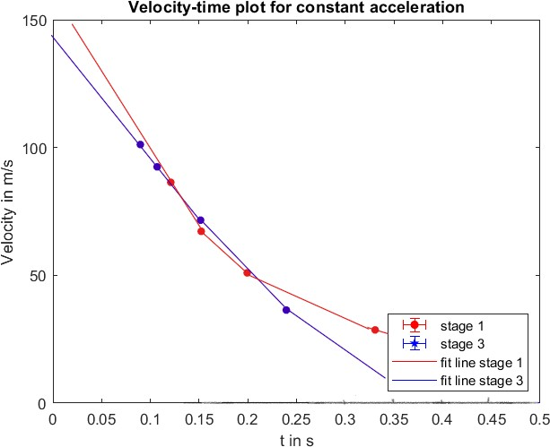

Figure 6: The velocity-time plots for constant acceleration.

The regression lines of the velocity-time plots are given by:

20 g weight: 𝑣20(𝑡) = (𝑎20 ± 𝑠𝑎20)𝑡 + (𝑏20 ± 𝑠𝑏20) = ( ± )𝑡, (26)

40 g weight: 𝑣40(𝑡) = (𝑎40 ± 𝑠𝑎40)𝑡 + (𝑏40 ± 𝑠𝑏40) = ( ± )𝑡. (27)

If the velocities are plotted against the positions of the light barriers, one obtains the velocity-position plot. The

points are lying on a square root function, because the velocity-position relation in the case of 𝑣0

= 0 𝑚 is given

𝑠

by

(𝑥) = √2𝑎0(𝑥 − 𝑥0). (28)

Squaring the velocity-position relation gives:

𝑣2(𝑥) = 2𝑎0(𝑥 − 𝑥0), (29)

i.e. the function 𝑣2(𝑥) is a linear function in *x*. Plotting then the squared velocities against the positions of the light barriers gives again data points that lie on a line and the slope of this line is according to equation (29) two times the acceleration. So calculating the regression line gives an alternative way to determine the acceleration.

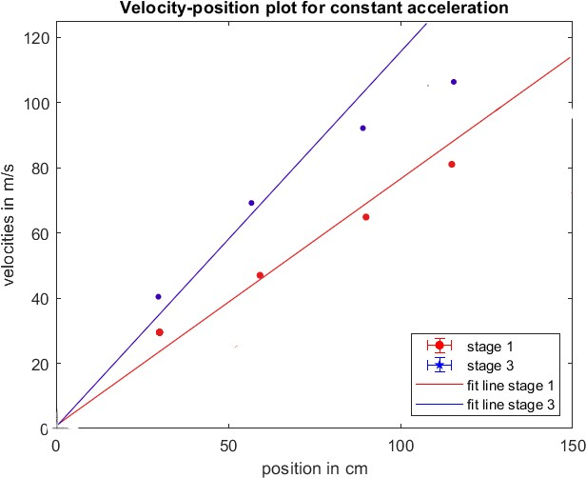

Figure 7: The velocity-position plot for constant acceleration.

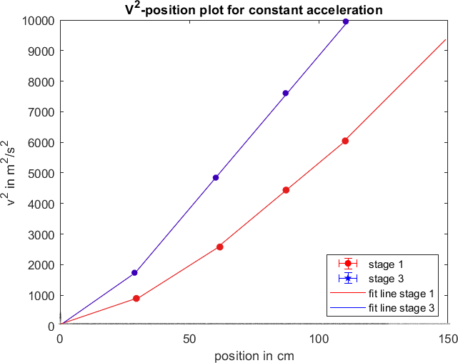

Figure 8: The 𝑣2-position plot for constant acceleration.

The regression lines of the 𝑣2-position plots are given by:

20 g: 𝑣202(𝑥) = (𝑎1 ± 𝑠𝑎1)𝑥 + (𝑏1 ± 𝑠𝑏1) = ( ± )𝑥 + ( ± ), (30)

40 g: 𝑣402(𝑥) = (𝑎3 ± 𝑠𝑎3)𝑥 + (𝑏3 ± 𝑠𝑏3) = ( ± )𝑥 + ( ± ). (31)

### Step 3: The results and answer to the question

The measurement value for the acceleration can be determined with the velocity-time plot and the 𝑣2-position plot. The measurement results for the acceleration follow in the case of the velocity-time plot directly from the slope and the case of the 𝑣2-position the acceleration is the slope divided by two:

Determination of the acceleration with the velocity-time plot:

|  |  |  |
| --- | --- | --- |
| acceleration for 20 g weight: 𝑎0 ± 𝑢(𝑎0) = ( | ± ) 𝑚/𝑠^2 , | (32) |
| acceleration for 40 g weight: 𝑎0 ± 𝑢(𝑎0) = ( | ± ) 𝑚/𝑠^2 . | (33) |

Determination of the acceleration with the 𝑣2-position plot:

acceleration for 20 g weight: 𝑎0 ± 𝑢(𝑎0) = ( ± ) 𝑚/𝑠^2 , (34)

acceleration for 40 g weight: 𝑎0 ± 𝑢(𝑎0) = ( ± ) 𝑚/𝑠^2 . (35)